Internet Programming Project Report
Student Information
- Name: Mahmut Siraç
- Surname: Özçelik
- Student Number: 220513431
- GitHub Username: siracozcelik440-beep
- Public Repository Link: https://github.com/siracozcelik440-beep/web-project.git
1) Aim of the Project and Target Users
The aim of this project was to design and implement a modern, responsive, and dynamic web application named Carbon Crown, developed as part of the Internet Programming course requirements. Carbon Crown is a conceptual high-end marketplace focused on premium carbon fiber motorcycle parts. The project was built to demonstrate full-stack thinking at the front-end level by combining semantic HTML5 structure, advanced CSS3 styling techniques, and dynamic JavaScript-based DOM manipulation. Although no real backend service is connected in this version, the architecture was intentionally designed to simulate data-driven behavior using JavaScript arrays and objects, reflecting how real-world e-commerce interfaces behave.
From an academic perspective, the project addresses core competencies expected in Internet Programming: structural correctness, visual consistency, interactivity, user-centered design, and maintainable code organization. The codebase is split into three foundational files—index.html, style.css, and script.js—with an assets directory for static media. This separation follows industry-standard concerns: content structure in HTML, presentation in CSS, and behavior in JavaScript.
The target users of Carbon Crown are primarily motorcycle enthusiasts, performance-focused riders, and customers who value premium aftermarket upgrades. The intended audience is not casual browsing users alone; it includes technically informed users who compare categories, evaluate products, and want a frictionless way to discover specialized components such as fairings, winglets, sliders, and intake covers. The UI therefore prioritizes clarity, quick filtering, and straightforward navigation. In addition, the contact form is designed for prospective buyers who seek tailored recommendations for specific motorcycle models.
In summary, Carbon Crown was built not only as a themed marketplace prototype but as a structured demonstration of practical web engineering principles taught in an Internet Programming curriculum.

2) Technical Deep Dive
2.1 HTML Structure (Semantic Layout and Content Architecture)
The HTML file (index.html) was constructed with semantic tags to ensure readability, accessibility, and proper document hierarchy. The key semantic elements are:
- <header> for branding and top-level navigation.
- <nav> for primary menu links (Home, Catalog, About, Contact).
- <main> for all core page content.
- Multiple <section> elements for distinct content modules.
- <footer> for closing metadata and quick navigation back to top.
This semantic structure is significant for both accessibility tools (such as screen readers) and search engines, because it provides contextual meaning beyond generic <div> usage. For example, the page starts with a sticky header containing the brand area and navigation links. Inside <main>, sections are ordered to match the user journey:
- Hero section: communicates the brand value proposition and provides immediate calls-to-action.
- Featured section: highlights selected products rendered dynamically through JavaScript.
- Catalog section: contains controls for searching and category filtering, plus a dynamic product grid.
- About section: explains business mission and trust perspective.
- Contact section: allows direct user inquiry through validated form fields.
The HTML also includes accessible attributes such as aria-label, aria-expanded, aria-controls, and aria-live where relevant. These additions improve usability for assistive technologies and reinforce inclusive design practices expected in professional front-end development.
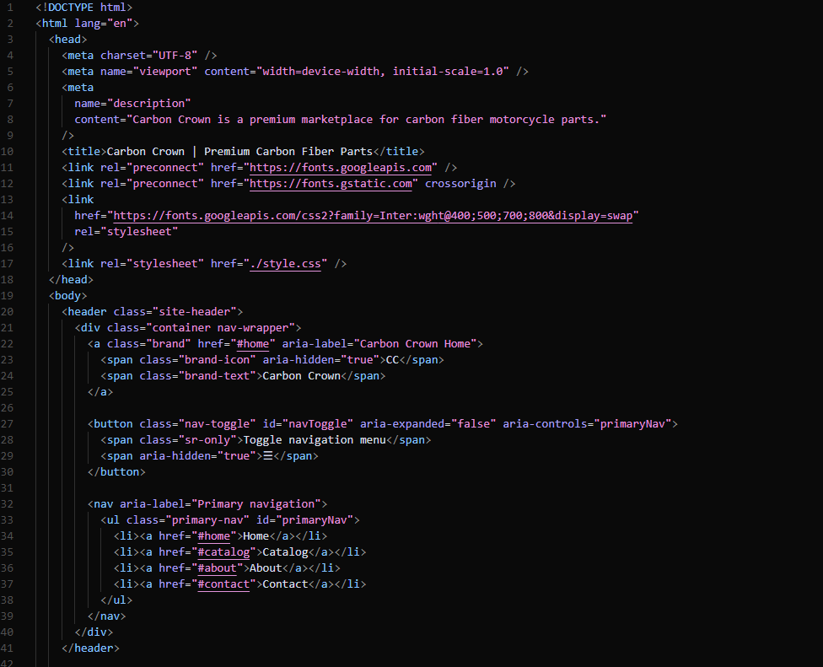
The provided code snippet from index.html demonstrates the structural integrity and modern web standards implemented in the Carbon Crown project. The analysis is categorized into three technical pillars:
1. Metadata and SEO Optimization
- Document Configuration: The <meta charset="UTF-8"> ensures universal character support, while the <meta name="viewport"> tag is critical for the project's responsive strategy, allowing the layout to scale correctly across different device widths.
- SEO Readiness: The <meta name="description"> tag provides a concise summary for search engine crawlers, defining the site as a "premium marketplace for carbon fiber motorcycle parts" to improve indexability.
- External Resource Integration: Preconnect links for Google Fonts are used to optimize loading performance, ensuring that typography—a key part of the brand identity—renders efficiently.
2. Semantic HTML5 Architecture
- Meaningful Hierarchy: The use of the <header> and <nav> tags instead of generic <div> elements establishes a clear document outline. This approach follows industry best practices for "content structure," making the codebase more maintainable and readable.
- Brand Identity: The logo area is wrapped in an <a> tag with an aria-label="Carbon Crown Home". This ensures that users relying on assistive technologies understand the destination of the link beyond the visual "CC" icon.
3. Inclusive Design and ARIA Implementation
- Mobile Navigation Logic: The <button class="nav-toggle"> serves as the trigger for the responsive mobile menu. The inclusion of aria-expanded="false" and aria-controls="primaryNav" allows screen readers to communicate the state of the menu (open or closed) dynamically to the user.
- Assistive Tech Optimization: The .sr-only (screen-reader only) class is used to provide textual instructions ("Toggle navigation menu") that are invisible to sighted users but essential for navigation clarity in non-visual browsing. Furthermore, aria-hidden="true" is applied to decorative icons to prevent redundant information from being announced.
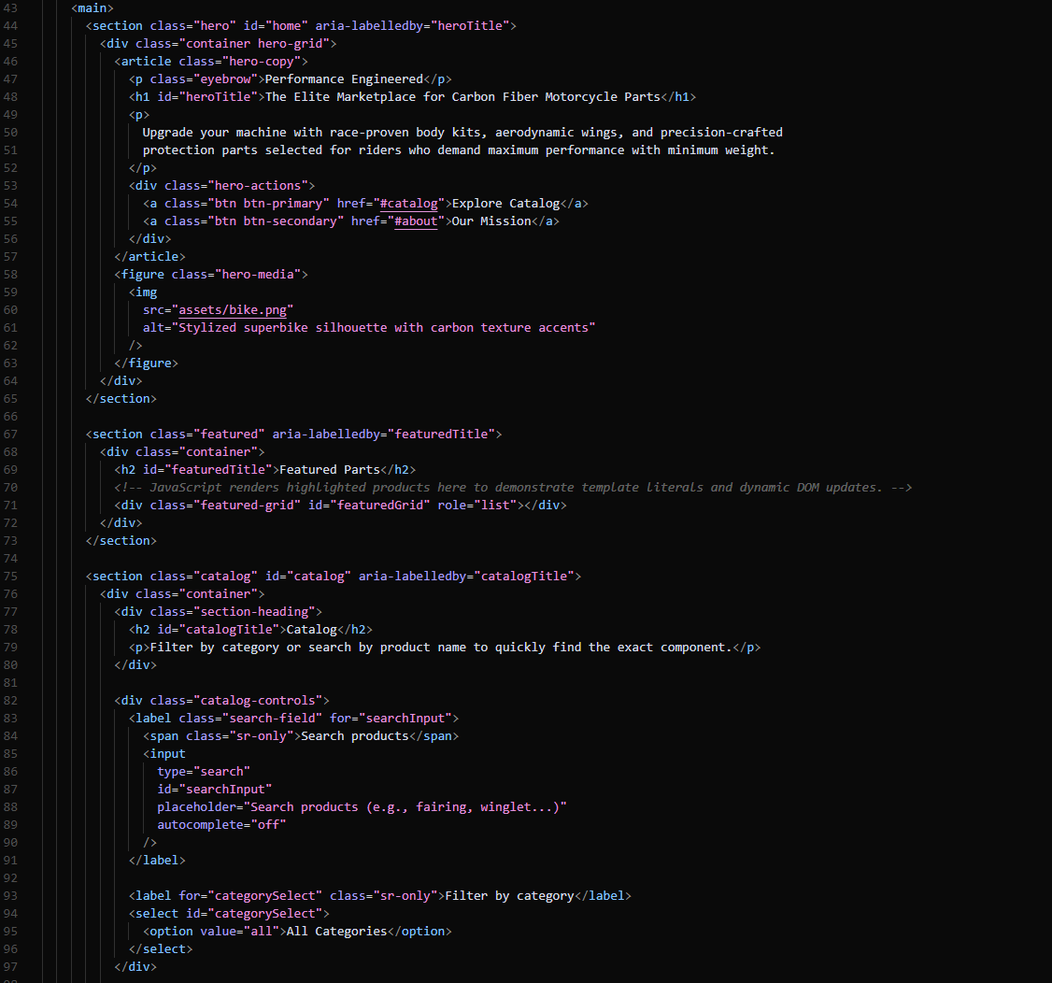
The provided snippet from the <main> element demonstrates a sophisticated approach to page organization, balancing static content delivery with dynamic "hooks" for JavaScript-driven updates. The implementation follows three key engineering principles:
1. Modular Sectioning and Semantic Clarity
- Hero Section: By using the <article> tag for the marketing copy and <figure> for the media asset, the code creates a clear distinction between textual information and visual illustration. The aria-labelledby="heroTitle" attribute creates a programmatic link between the section and its primary heading, aiding navigational clarity for screen readers.
- Functional Decomposition: Each major area—Hero, Featured, and Catalog—is encapsulated within its own <section>, ensuring a clean document flow that mirrors the user journey described in the UX evaluation.
2. Dynamic Data Infrastructure (JavaScript Hooks)
- Template Integration: The div with id="featuredGrid" and role="list" on line 71 is a critical "hook" for the JavaScript engine. It is intentionally left empty in the HTML to be populated dynamically via template literals, as noted in the developer comment on line 70.
- Catalog Interactivity: The search and filter controls are structured to facilitate real-time events. The use of specific IDs (searchInput, categorySelect) allows for precise targeting by JavaScript event listeners, enabling the seamless "filter-while-typing" behavior mentioned in the report.
3. Advanced Accessibility and UX Integration
- Inclusive Controls: Even though the search and filter inputs are visually clear, the implementation includes .sr-only labels ("Search products" and "Filter by category"). This ensures that the purpose of the inputs is explicitly clear to non-visual users without cluttering the visual design.
- Programmatic Relationships: The consistent use of the for attribute in <label> tags and matching id attributes in <input> and <select> elements follows the highest standards for form accessibility. This not only aids assistive technology but also increases the clickable hit-area for users, improving overall usability.
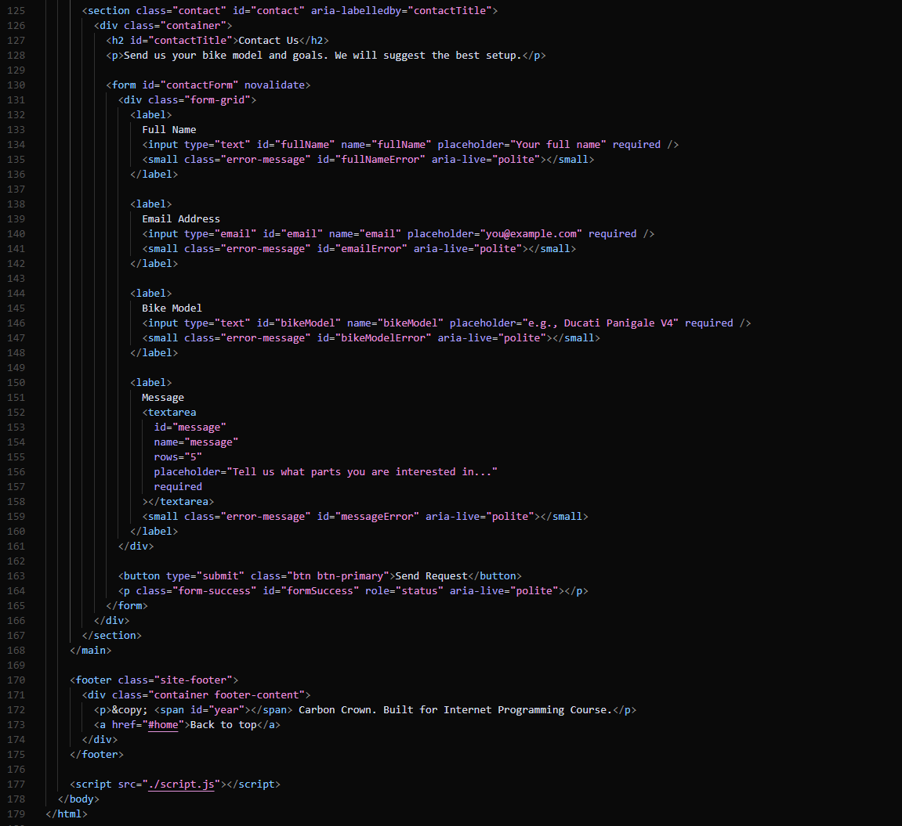
The concluding segment of index.html showcases the integration of advanced form handling and persistent global elements. The technical implementation focuses on three primary areas:
1. Custom Form Architecture and Validation Hooks
- Native Validation Override: The <form> element includes the novalidate attribute. This is a strategic choice that disables default browser tooltips, allowing the custom JavaScript validation system described in the report to take full control over the user experience.
- Dynamic Error Communication: Each input field is accompanied by a <small> element with the class error-message and a unique ID. These act as containers for real-time JavaScript feedback. The inclusion of aria-live="polite" ensures that as these error messages are populated by JavaScript, they are immediately and clearly announced to users of assistive technologies.
- Success Feedback: The <p id="formSuccess" role="status"> element on line 164 is reserved for final submission confirmation. Using role="status" ensures that successful interactions are prioritized for accessibility feedback.
2. Global Footer and Dynamic Data Injection
- Semantic Ending: The <footer> tag is used to provide a clear end to the document hierarchy. It contains essential branding information and a "Back to top" navigation link, which improves overall UX for long-scrolling pages.
- JavaScript Integration Point: The <span id="year"> on line 172 serves as a dynamic placeholder. Instead of hardcoding the date, the project uses a JavaScript function to inject the current year, ensuring the copyright information is always up-to-date without manual intervention.
3. Performance and Script Management
- Optimized Script Loading: The <script src="./script.js"> tag is placed at the very end of the <body> on line 177. This is a performance best practice that ensures the entire HTML structure is parsed and rendered by the browser before the JavaScript logic begins to execute, preventing "render-blocking" issues and improving initial page load speed.

2.2 CSS Styling (Design Language, Visual Hierarchy, and Responsiveness)
The CSS file (style.css) implements a modern visual identity through three major strategies: design tokens (CSS variables), layout systems (Grid + Flexbox), and smooth interaction transitions.
a) Design Tokens and Color Palette
A :root block defines custom properties such as:
- --bg, --surface, --surface-elevated for layered dark backgrounds.
- --text, --text-muted for readability hierarchy.
- --accent, --accent-strong for action and emphasis.
- --success, --danger for form feedback states.
This approach centralizes visual values and makes the design easier to maintain or theme later. Instead of hardcoding colors repeatedly, each component consumes shared variables. This is an industry-standard strategy that improves consistency and refactoring speed.
The selected palette creates a premium technical aesthetic that matches the brand concept (high-performance carbon products). Blue accent tones signal technology, precision, and trust, while dark surfaces increase contrast for content blocks and cards.
b) Layout Methodology: Flexbox and CSS Grid
Both layout systems were used intentionally based on problem type:
- Flexbox is used in one-dimensional alignment scenarios, such as:
  - Header content distribution (brand vs nav).
  - Button group alignment in hero actions.
  - Horizontal control arrangement in catalog filters.
- Grid is used in two-dimensional sections, such as:
  - Hero and About split layouts.
  - Featured and product card grids.
  - Contact form structure.
For example, product cards use a responsive grid pattern: grid-template-columns: repeat(auto-fit, minmax(225px, 1fr)); This automatically adjusts column count based on available viewport width, reducing the need for rigid breakpoint logic.
c) Responsive Behavior
Media queries optimize display for multiple device classes:
- Around tablet widths, hero/about sections collapse from two columns into one for better vertical flow.
- On smaller mobile widths, the navigation transforms into a toggled dropdown menu.
- Form fields reorganize into a single-column stack for touch usability.
The responsive strategy is content-aware rather than purely device-specific. Instead of only targeting screen categories, the design adapts when readability, spacing, or interaction comfort requires it.
d) Motion and Interaction Quality
Subtle transition effects were applied to links, buttons, and cards. These animations provide visual feedback (hover, focus, elevation) and make the UI feel responsive without becoming distracting. Smooth behavior contributes to perceived quality, which is important in premium product interfaces.
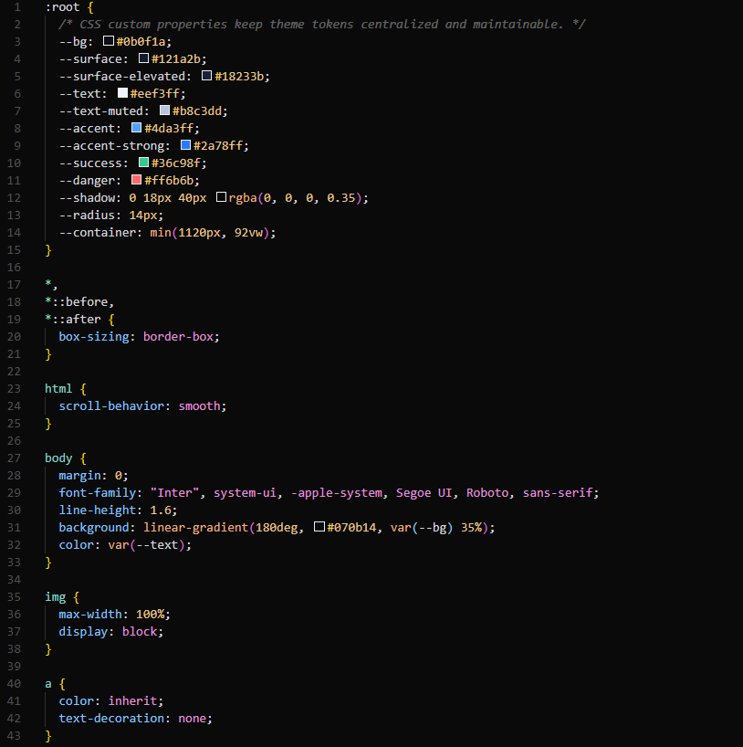
The initialization of the style.css file establishes a centralized theme management system and ensures cross-browser visual consistency. The implementation is divided into three critical technical strategies:
1. CSS Custom Properties (Design Tokens)
- Theming and Scalability: The :root block defines a comprehensive set of custom properties (variables) for colors, spacing, and UI components . By using tokens like --bg, --accent, and --radius, the project adheres to the "Don't Repeat Yourself" (DRY) principle . This allows for instant global theme updates (e.g., changing the accent blue) without modifying individual component styles.
- Visual Hierarchy: Colors are semantically named (e.g., --text-muted and --surface-elevated) to reflect their functional role rather than just their hex value . The inclusion of a centralized --container variable ensures that the maximum content width remains consistent across all pages, maintaining the project's structural integrity.
2. Global Reset and Box Model Standardization
- Predictable Layouts: The universal selector * along with ::before and ::after pseudo-elements applies box-sizing: border-box to every element. This is a fundamental industry standard that ensures padding and borders are included in an element's total width and height, preventing layout breaks and making responsive grid calculations more predictable .
- User Interaction: The scroll-behavior: smooth property in the html block enhances the user experience by providing a polished transition when users click internal navigation links (e.g., "Back to top" or "Explore Catalog") .
3. Base Element Typography and Fluidity
- Modern Font Stack: The body selector utilizes a "system-ui" font stack beginning with Inter. This ensures that the application feels native to any operating system while prioritizing the high-readability aesthetics of the Inter typeface.
- Responsive Media Foundation: The img selector includes max-width: 100% and display: block. This prevents images from overflowing their parent containers on smaller screens, serving as the first layer of the project's responsive design strategy .
- Dynamic Backgrounds: The background uses a linear-gradient that blends a hardcoded dark tone with the --bg variable. This creates a subtle depth effect in the hero section, contributing to the "premium technical aesthetic" described in the report .

2.3 JavaScript and Application Logic (Dynamic Rendering + Event-Driven Interactivity)
The JavaScript file (script.js) acts as the behavior layer of the application. Its architecture follows a modular function-based approach with clear separation between data, rendering, and interaction handlers.
a) Dynamic Rendering with Template Literals
Product cards are generated from JavaScript objects and inserted into the DOM using template literals. Rather than writing static HTML for each product, one rendering function creates reusable card markup based on object properties (name, category, price, image, description, stock). This approach has major advantages:
- Reduces markup duplication.
- Keeps UI synchronized with data state.
- Makes future scaling easier (new products require only data additions).
The same logic is reused for both featured products and full catalog rendering, showing good code reuse principles.
b) Event Listeners and Reactive UI
The application uses event listeners for live interactivity:
- input event on the search field for immediate filtering while typing.
- change event on category selector for category-based filtering.
- click event for mobile nav toggle behavior.
- submit and input events in the contact form for real-time validation.
This event-driven model creates a reactive user experience where page updates happen instantly without refresh. It reflects modern single-page interaction patterns common in professional web apps.
c) Validation System
The contact form uses field-level validators stored in a dedicated object. Each field has a validation function returning either an empty string (valid) or an error message (invalid). Errors are displayed beside the related field and aria-invalid is updated accordingly.
This approach provides:
- Immediate feedback (better UX than submit-only validation).
- Reusable and readable validation logic.
- Cleaner maintenance because rules are centralized.
d) Auxiliary Enhancements
Small but meaningful logic includes:
- Dynamic year injection in footer (new Date().getFullYear()).
- Auto-closing mobile navigation when a nav link is selected.
- Empty-state handling when no products match filtering criteria.
Together, these details elevate the project from a simple static page to a functional interface prototype.
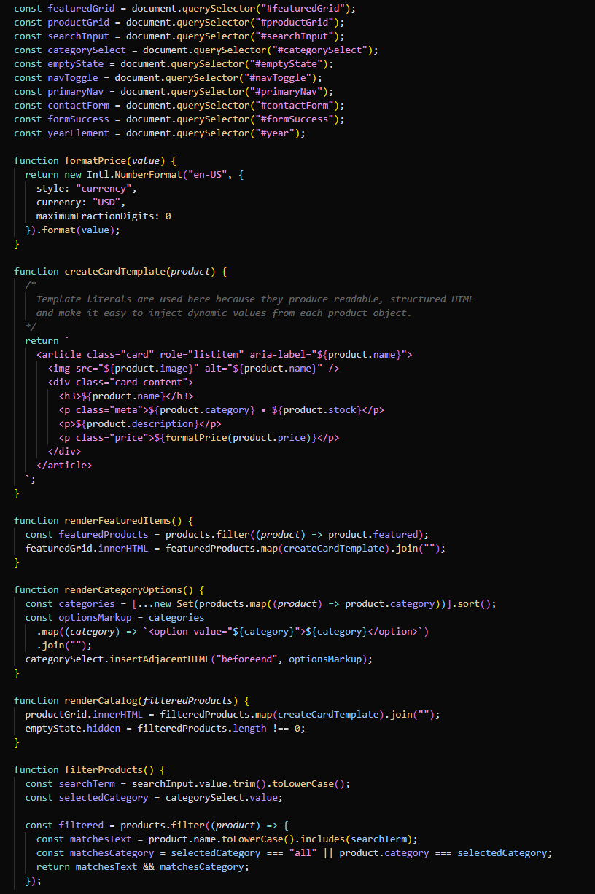
The script.js implementation utilizes modern ES6+ features to create a reactive and data-driven user experience. The technical architecture is defined by the following four pillars:
1. DOM Reference Management
- Global Element Selection: The script begins by caching DOM elements using document.querySelector. By selecting critical hooks like #featuredGrid, #searchInput, and #categorySelect, the application ensures efficient access to UI components for subsequent updates .
- Utility Functions: The formatPrice function leverages the Intl.NumberFormat API. This provides a localized and professional currency display ($USD), ensuring that price data is formatted correctly before being presented to the user.
2. Dynamic UI Generation via Template Literals
- Reusable Templates: The createCardTemplate function is a prime example of "Dynamic Rendering" . Instead of static HTML, it uses backticks (template literals) to inject product properties—such as ${product.name} and ${product.image}—directly into a structured HTML string.
- Accessibility Integration: The generated cards include role="listitem" and aria-label, ensuring that the dynamically injected content remains accessible to screen readers .
3. Functional Data Transformation
- Array Processing: The rendering functions (renderFeaturedItems, renderCatalog) utilize higher-order functions like .filter() and .map(). This functional approach allows the application to:
  - Isolate featured products from the main array.
  - Transform each data object into an HTML card.
  - Use .join("") to convert the resulting array into a single string for seamless innerHTML injection.
- Unique Set Generation: The renderCategoryOptions function uses the new Set() constructor to automatically extract unique categories from the product list. This ensures the filter dropdown is always synchronized with the available data without manual entry.
4. Reactive Search and Filter Engine
- Real-Time Logic: The filterProducts function implements the core interactivity of the marketplace . It captures the searchTerm and selectedCategory to create a new subset of products .
- State-Aware UI: Inside renderCatalog, the script updates the emptyState.hidden property. If a user’s search returns no results, the application dynamically displays an "empty state" message, providing essential feedback and improving the overall UX.
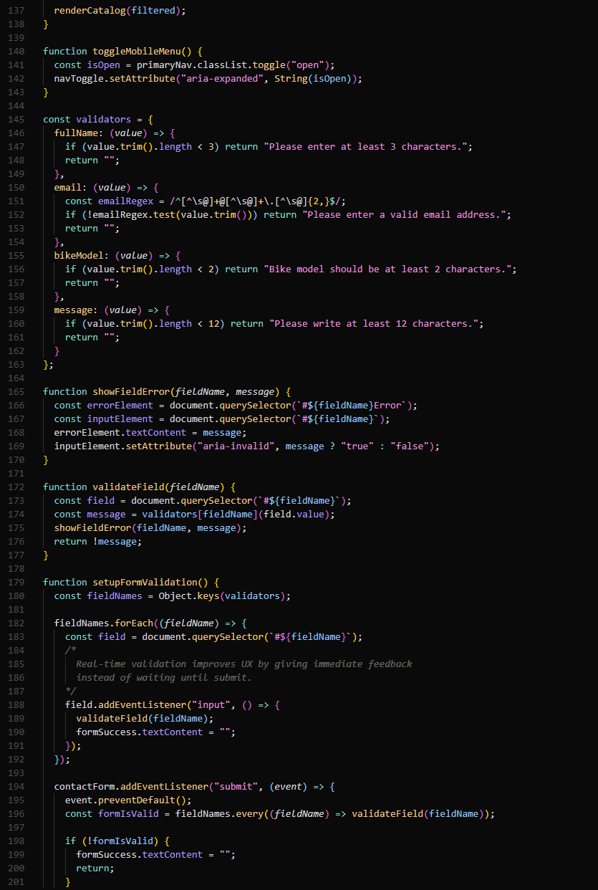The final segment of script.js focuses on enhancing user accessibility and securing data integrity through an event-driven architecture. The implementation is structured around three core functional areas:
1. Responsive Navigation Management
- Stateful Toggling: The toggleMobileMenu function utilizes the classList.toggle method to manage the visibility of the primary navigation on smaller viewports.
- ARIA Synchronization: To maintain accessibility standards, the function dynamically updates the aria-expanded attribute on the navigation toggle button. This ensures that users with screen readers are immediately notified of the menu's state (open vs. closed), fulfilling professional inclusive design requirements.
2. Scalable Validation Architecture
- Object-Literal Validation Rules: The validators object serves as a centralized "rule engine". Each field (e.g., fullName, email, message) is assigned a specific validation function.
- Regex Implementation: For the email field, a Regular Expression (Regex) is employed to ensure that the user input follows a standard you@example.com format.
- Clean Logic Separation: By returning either an error message or an empty string, the system separates the logic of what makes a field valid from the mechanism of how errors are displayed.
3. Real-Time Feedback and Submission Control
- Immediate Feedback (UX): The setupFormValidation function attaches input event listeners to every form field. This provides "real-time validation," which significantly improves the User Experience by alerting users to errors as they type rather than waiting until they attempt to submit the form.
- Dynamic DOM Feedback: The showFieldError function bridges the script and the UI by injecting error text into the relevant <small> elements and updating the aria-invalid attribute .
- Submission Prevention: The contactForm event listener uses event.preventDefault() to intercept the native browser submission. It performs a final check across all fields using .every(); if any field remains invalid, the form will not submit, preventing incomplete or incorrect data from being processed .

2.4 Data Handling (Simulated Database via Arrays/Objects)
A key requirement of the project was to simulate data handling without a real database. This was achieved using a JavaScript products array containing object entries for each catalog item. Each object includes structured attributes such as:
- id
- name
- category
- price
- stock
- featured
- image
- description
This mirrors a simplified backend payload. The application treats this structure as its source of truth and performs operations such as:
- Mapping to card components.
- Filtering by text and category.
- Selecting featured records (featured === true).
- Building category dropdown options dynamically from unique categories.
From an academic perspective, this demonstrates understanding of how frontend applications consume and transform structured data. If a backend API were added later, the same render and filter functions could remain mostly unchanged, showing good forward compatibility in architecture.
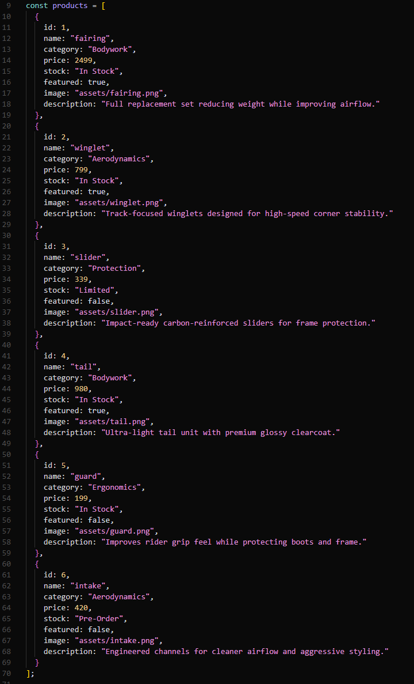
The implementation of the products array serves as the application's central "source of truth," mimicking the structure of a backend API response. The following technical breakdown explains the significance of this data architecture:
1. Structured Data Modeling
- Object Array Implementation: The dataset is structured as an array of objects, where each object represents a unique product entity. This is an industry-standard format for managing collections of data in frontend development.
- Comprehensive Attribute Schema: Each entry follows a strict schema with keys such as id, name, category, price, stock, featured, image, and description . These attributes allow the application to perform complex logic, such as identifying items for the "Featured Parts" section (using the featured: true flag) or determining inventory status.
2. Foundation for Dynamic Rendering
- Decoupled UI and Data: By storing product information in this array, the project decouples the visual interface from the raw data. This allows the JavaScript rendering functions to iterate through the array and inject content into the DOM dynamically, reducing manual HTML maintenance.
- Asset Path Management: The image property specifically uses the assets/filename.png format. This addresses the initial technical challenges regarding asset paths, ensuring that every dynamically generated card points to the correct physical file in the project directory.
3. Enabling Advanced Logic and Scalability
- Filter and Search Compatibility: The structured category and name fields enable the real-time search and category filtering features mentioned in the report. JavaScript functions can easily filter this array based on user input to update the display instantly.
- Future Compatibility: From an engineering standpoint, this architecture is "forward-compatible". If a real backend or database were to be integrated later, the current rendering logic would remain mostly intact, as it is already designed to consume structured JSON-like data.

3) User Experience (UX) Evaluation
The UX strategy centers on clarity, speed, and predictability. Navigation links are always visible on larger screens and neatly collapsible on small devices. Section ordering follows user intent: first attention capture (Hero), then trust and product evidence (Featured/Catalog), then brand context (About), and finally conversion step (Contact).
Catalog controls are intentionally placed above product results so users can instantly refine what they see. Real-time search reduces interaction cost because users do not need to press a separate search button. Category filtering complements this by supporting both exploratory browsing and targeted selection.
Typography and spacing preserve readability across devices. Visual hierarchy is clear: headings, muted secondary text, emphasized prices, and actionable buttons with accent color contrast. Input focus states are visible and accessible, reducing confusion during form completion.
The contact form’s immediate validation strengthens usability and reduces submission errors. Instead of generic failure at the end, users receive direct field-by-field guidance. This is important in practical form design and aligns with user-centered design standards.
Overall, the interface supports both first-time and returning users by making pathways obvious and interactions low-friction.

4) Screenshots and Visual Documentation
A) Home / Hero Section
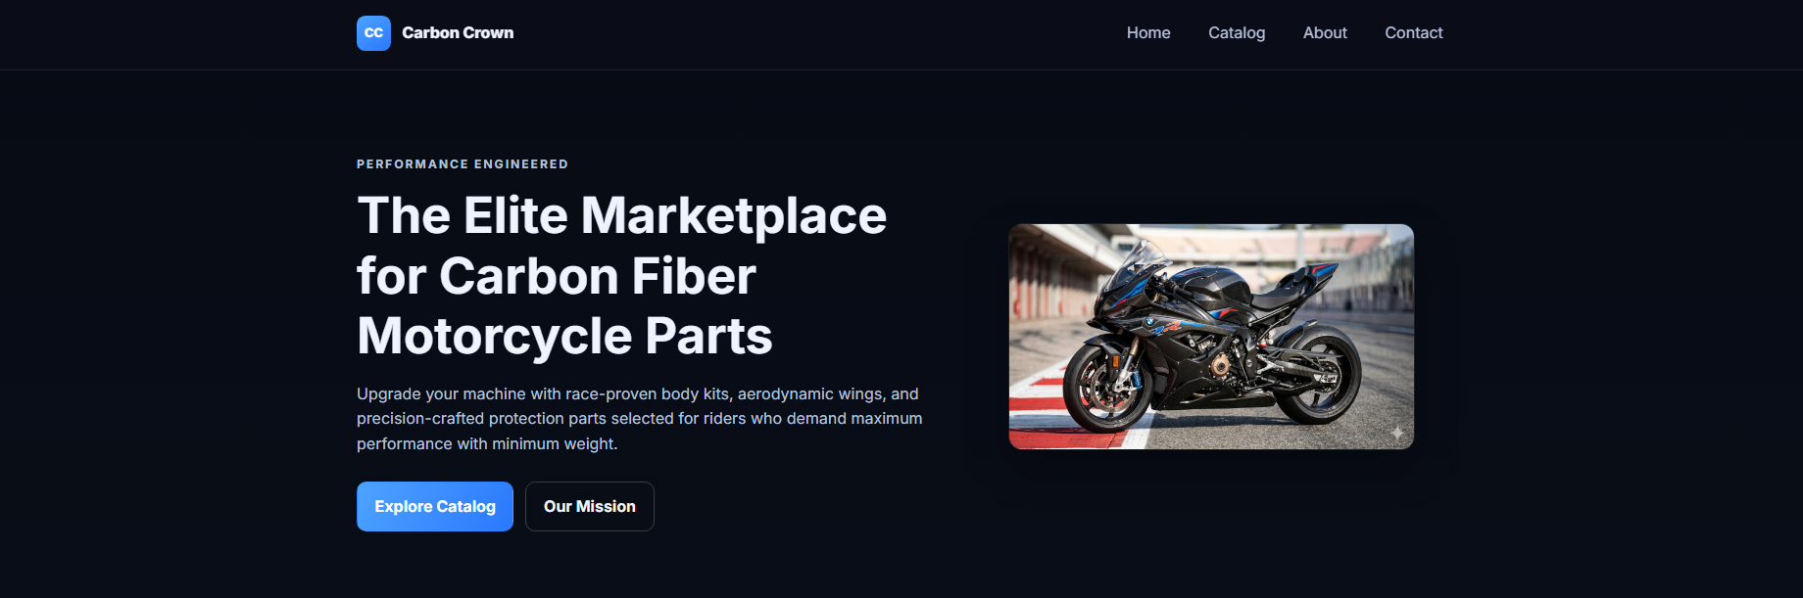This screenshot should display the hero banner, brand identity, and top navigation in one frame. It should highlight how the value proposition is presented immediately to the user with strong heading typography and two clear call-to-action buttons. The image area in the hero visually reinforces the high-performance motorcycle theme and creates first-impression impact. This screenshot is important because it demonstrates the project’s opening UX strategy and visual language consistency.
B) Catalog + Filtering Interaction
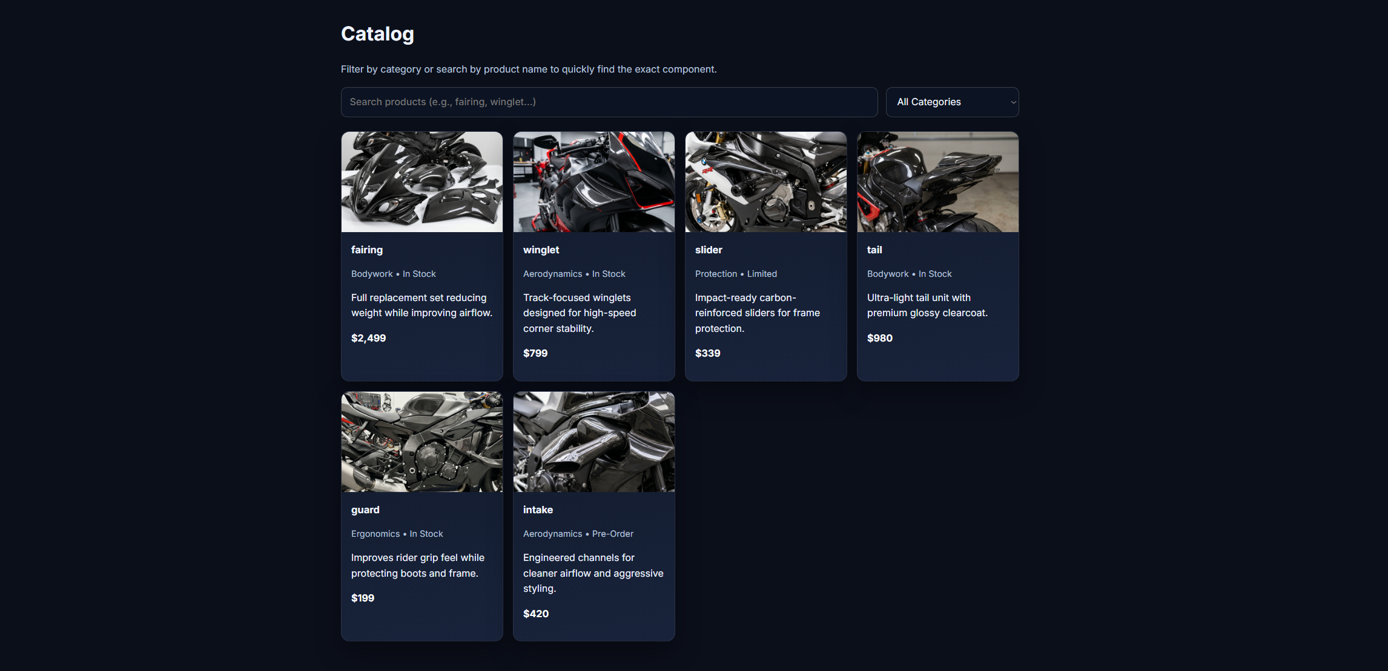This screenshot should show the catalog controls (search input and category dropdown) and a populated product grid. Ideally, capture a state where filtering is active so it is clear that product cards are dynamically changing based on user input. Visible product cards should include image, category/stock metadata, description, and formatted pricing to prove data-driven rendering quality. This screenshot is critical because it documents the JavaScript interactivity and validates that the page is not static.
C) About Section
This screenshot should contain the mission text and accompanying visual media block side-by-side (or stacked on smaller devices). It should demonstrate how the project communicates trust and purpose beyond product listings, which is important in professional marketplace design. Layout spacing, contrast, and typographic hierarchy should be visible to show readability and brand tone. This section matters because it reflects content strategy and not just technical implementation.
D) Contact Form with Validation State
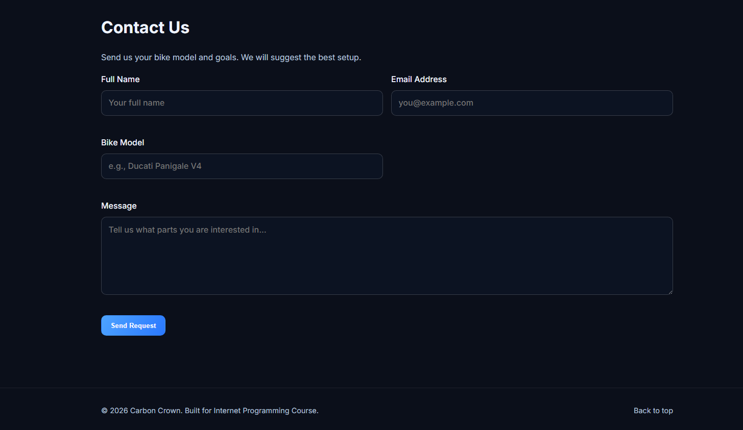This screenshot should show the contact form with at least one validation message visible (for example, invalid email or short message). It should also show how error text appears contextually below the corresponding input, proving real-time validation behavior. If possible, include a second screenshot of successful submission feedback to demonstrate complete interaction flow. This evidence is essential because form validation is one of the required dynamic JavaScript components.

5) Challenges Encountered and Solutions Applied
Challenge 1: Asset Path and Filename Mismatch
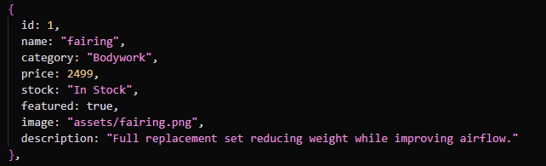
One major issue encountered was broken images caused by inconsistent file paths and filename assumptions. Initially, some image paths referenced SVG files while actual project assets were stored as PNG files. In addition, relative path style (./assets/... vs assets/...) and naming consistency needed alignment.
Solution:
All product image paths in script.js were updated to use the required assets/filename.png format with exact filename matching. The hero image source in index.html was also corrected to point to the existing bike asset. This resolved rendering failures and ensured consistent cross-file asset referencing.

Challenge 2: Responsive Grid Behavior Across Screen Sizes
Another technical difficulty was making sure card layouts and section structures remained stable across desktop, tablet, and mobile breakpoints. Early layouts can appear balanced on large screens but become crowded or misaligned on narrow devices.
Solution:
A hybrid strategy was used: CSS Grid for product/cards and major section splits, and Flexbox for linear controls and button groups. Media queries were added at key breakpoints to collapse two-column structures into one column and to optimize the navigation experience for mobile. This prevented overflow, preserved readability, and maintained interaction quality.

Challenge 3: Balancing Dynamic Rendering with Clean Code Organization
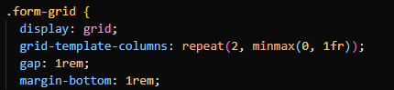
When implementing dynamic catalog rendering, there is a risk of tightly coupling business logic with DOM updates, leading to repetitive or hard-to-maintain code. Handling featured items, full catalog listing, and filtering in separate places can quickly become inconsistent.
Solution:
Reusable functions were introduced (createCardTemplate, renderCatalog, renderFeaturedItems, filterProducts) to separate responsibilities. Template literals standardized card markup generation from data objects, while event listeners triggered targeted updates. This improved maintainability and reduced code duplication, making the project easier to extend.


Conclusion
The Carbon Crown project successfully fulfills core Internet Programming requirements by combining semantic document structure, advanced responsive styling, and dynamic JavaScript behavior in a clean and maintainable architecture. The project demonstrates both technical competence and design awareness: content is structured meaningfully, visual identity is consistent, interactions are immediate, and data is handled through scalable object-driven logic.
From an academic standpoint, the implementation shows practical understanding of front-end engineering workflows used in modern web development. Even without a real backend, the simulated database approach and render/filter pipeline mimic realistic product application behavior. The result is a professional, course-appropriate project that can be further expanded into a fully functional marketplace in future iterations (e.g., backend integration, authentication, persistent cart system, and API-based product management).

